**MDF Rose Engine Lathe 2.0**

**with Stepper Motor Drive**



**Instructions for Building**

**Base & Headstock**

**Version 1.2**

**04 September 2022**

This document is intended to help one unfamiliar with the MDF rose engine to build one easily. It is designed to go with the kit you can purchase from [www.ColvinTools.com](http://www.ColvinTools.com).

There are some variations from the ideas documented by Jon Magill at [www.rogueturner.com](http://www.rogueturner.com/). Where this is the case, we have tried to document such changes and provide the reason for the change.

This document is also designed to use a stepper motor for driving the spindle.

If you have any questions, please contact us at [ColvinTools@Gmail.com](mailto:ColvinTools@Gmail.com).

Good luck and we hope you enjoy this machine as much as we.

Rich Colvin & Jack Zimmel

Table of Contents

Getting Started 4

Accuracy 4

The MDF for the Base and Headstock 5

Parts You Will Need 5

General Instructions 5

Lathe Headstock Instructions 6

Before Assembly 7

Assembly of the Headstock 16

After Assembly 17

Lathe Base Instructions 20

Before Assembly 22

Rubber Support 33

Assembly of the Base 36

After Assembly of the Base 37

Additional Parts 38

Centering Block 38

Bungie Block 38

Cross Slide Base Instructions 39

Drilling Holes and Assembly 41

# Getting Started

As you get started with building this machine, please consider making the machine exactly according to the outlined instructions. There are lots of ways you can modify this, and, quite frankly, the MDF rose engine encourages experimentation. But it is best to attempt those modifications after understanding how it works. Some ideas which sound grand may not appear so after understanding how the machine works (we speak from experience).

If you have any questions on the terminology in this document, check out the “Ornamental Turning Book of Knowledge” ([www.OTBoK.info](https://www.otbok.info/)).

Throughout this document, I’ve tried to show the MDF in its native color of tan/brown. There are differences in the images I captured from the CAD drawing made, but those are not representative of the machine’s differences.

Unless otherwise noted, the MDF is ¾” thick.

## Accuracy

When making the MDF Rose Engine, there are certain aspects which must be managed for accuracy in the work.

### Headstock

1. The distance from the center of the rocking pivots to the center of the spindle should be 12 inches. The rosettes are designed around this.
2. The rocking pivot points need to be aligned with the spindle.

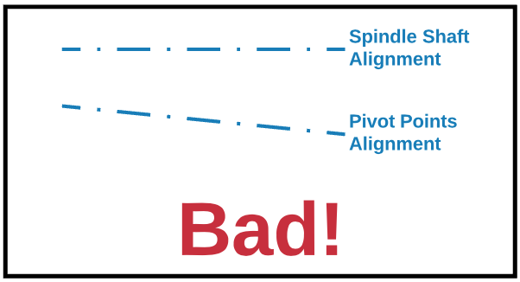

## The MDF for the Base and Headstock

The lathe’s base and headstock can be cut from a 4’ x 8’ sheet of MDF, or you can buy a kit with the pieces pre-cut.

| Package | Contents | Source(s) |
| --- | --- | --- |
| **MDF Rose Engine 2.0 Case Kit** | All the MDF pieces for the body and headstock, already cut to size and ready for assembly. Also includes the sheet of steel for the bed. | The full kit is available from [ColvinTools.com](http://www.colvintools.com/) |

If you choose to cut your own, you should be able to get a standard sized (8’ x 4’ x ¾”) piece of MDF from my local big-box store (Lowes). The default design from Jon Magill was to use 1/2 a sheet (4’ x 4’), but with the newer design in the 2.0 model, a whole sheet will be needed. It can all be obtained from a full sheet, with some to spare. Also, the extra material is useful for re-making parts if you mess up (or at least I did), and it is also useful for making some jigs and fixtures that are always useful around the shop.

## Parts You Will Need

The other parts you will need to make a complete MDF rose engine lathe can be purchased or made. Details of these are also shown on [ColvinTools.com](https://www.colvintools.com/). We do highly recommend that you not attempt to make the parts in the base kit. Those have tight tolerances and are difficult if you are not a machinist with access to a good metal working shop.

## General Instructions

**Tapping Threads in MDF**

1. Drill the hole
2. Fill it with superglue and let it dry
3. Tap the threads
4. Fill the threads with superglue again
5. Let it dry overnight.
6. Tap the threads a second time.

**Painting Your Machine**

It seems to be a mixed bag on who paints their machine, and who does not. The only limitation I have seen with the painting of mine is that the fading wedge doesn’t slide up and down as easily after painting it.

If you do paint it, I recommend brushing or rolling on paint vs. spray painting. When I have tried to paint MDF, The MDF really absorbed the paint in some places, and less so in others. Really looked splotchy and the color was not consistent. One person said it took 5 coats of spray paint.

# A close up of a box Description automatically generatedLathe Headstock Instructions

The headstock is these pieces:

**H5**

* **H1** – The part closest to the user. In the picture to the right, this is the one which is labeled, “MDF Rose Engine Lathe 2.0”.
* **H2** – The part on the back side, opposite H1.
* **H3** – the part on the right (away from the drive).

**H2**

* **H4U & H4L** – The two parts (one upper, one lower) to the left (the stepper motor drive end)
* **H5** – The top of the headstock
* **H6U & H6L** – The bottom of the headstock.

**H3**

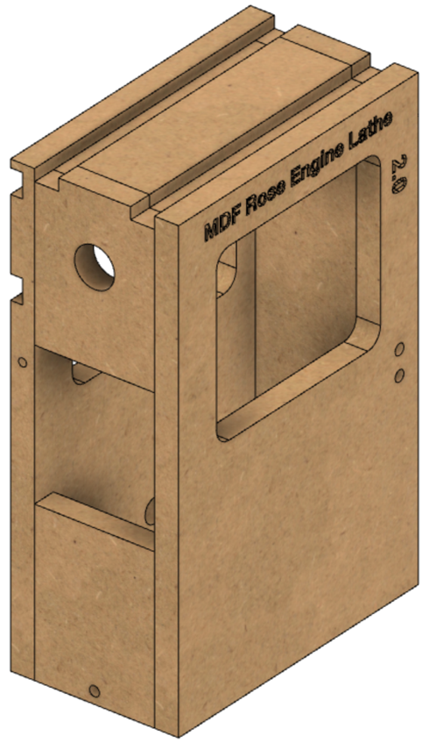Cutout these pieces as noted below. They are shown in the order I recommend pursuing.

**H5**

**H1**

**H2**

**H3**

**H5**

**H4U**

**H4L**

**H1**

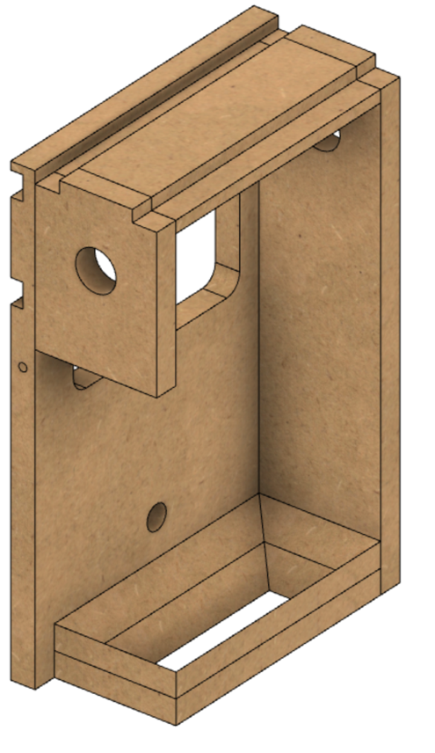

**H4U**

**H3**

**H2**

**H6U**

**H6L**

## Before Assembly

The following instructions should be followed before assembling the headstock.

### H1 – Side Closest to the User

For the window in the piece, most machines

I’ve seen have radiused corners. That tends to look better but is not critical. The ½” radius is shown for an example.

The two holes on the right which are marked for 25/64” (0.3906”) are for the wedge block. They are tapped for 3/8”-16 threads.



**½” Radius**

**(typ)**

**6 ½”**

**5 ½”**

**1 ½”**

**9 ½”**

**1 ½”**

**14 ½”**

**7 ½”**

**8 ¼”**

**25/64” diam**

**3/4”**



**7 7/8”**

**5/16” diam**

**1”**

**25/64” diam**

**3/8”**

### H2 – Side Furthest from the User

The cuts for the T-Track are shown in the side view (the left pic). These dimensions are critical as they put the T-Track centered at 1 ½” above and 1 ½” below the spindle’s center. The T-Track is set to be flush with the surface and is designed to use T-Track which is ¾” wide x 3/8” tall.

As with **H1**, the window in the piece usually has radiused corners. That tends to look better but is not critical.

**⅜”**



**25/64” diam**



**14 ½”**

**2 5/8”**

**5 5/8”**

**6 ½”**

**5 ½”**

**½” Radius**

**(typ)**

**¼”**

**¾”**

**¾”**

**2 ¼”**

**9 ½”**

**4 ¾”**

**1” diam**

**1 ½”**

**1”**

The 1” hole at the bottom is for the wires to pass thru from the stepper motor.

The dimension shown as 11 ⅞” could be less, and moving the hole up to around 11” may be a good choice. Don’t increase the distance much though as it could be covered up by the two bottom pieces (**H6U** and **H6L**).

**NOTE** : DO NOT DRILL ANY OTHER HOLES INTO THESE PIECES AT THIS TIME.

### Headstock Pivots

The layout of the headstock pivots, and how they fit into the various pieces of MDF are outlined below. Both sides are the same (just mirror images), so only one is detailed.



**H4L**

**B3**

**B4**

**H3**

#### A picture containing diagram Description automatically generated3/8”-16 Set Screw with 60° Bevel

For this piece, start with McMaster-Carr p/n 91375A632. They come in a package of 10 which is good as the first ones you make may need to be re-done.

The part in the drawing to the right where the cup point is shown will have to be made into a 60° bevel. This is typically done on a metal lathe.

The resulting piece will look as it does to the left. These are included in the Base System Kit sold by Colvin Tools.

#### Graphical user interface, diagram Description automatically generated3/8”-16 Bolt with Head Thinned to 1/8” with a 60° Recess

For this piece, start with McMaster-Carr p/n 92620A622.

They come in a package of 50 which is good as again, the first ones you make may need to be re-done.

The head, shown here as ¼” thick, will need to be thinned down to be 1/8”. Care should be taken when doing this to not take away the temper of the screw. This is a pivot point and will get a decent amount of wear over the years (especially if you love using your machine as much as I do!).

The head will need to have a 60° . This is typically done on a metal lathe.

The resulting piece will look as it does to the left. These are included in the Base System Kit sold by Colvin Tools.

#### Assembled Pieces

The assembled components will look like the image below when in place.

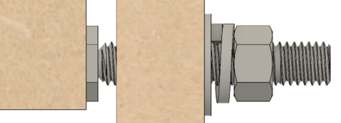

**H3**

**B4**

### A picture containing clock Description automatically generatedH3 – Right Side

**⅜”**

**¾”**

**1 ⅞”**

Drill the top and bottom holes whilst the fences are setup on the drill press. As noted in the section on **Accuracy** (pg. 4), the alignment of these two holes on both ends is critical.

**2 ⅛”**

**Note 1**: The diameter of the hole at the top should match the bronze bushing. It is shown here as 1 ½”, but size it to fit your bushings.

**1 ¼” Diam**

The indentations at the top are designed to use T-Track which is ¾” wide x 3/8” tall.

The hole marked for drilling 5/16” at the bottom is for the pivot.

The 5/16” hole will be tapped for a 3/8"-16 thread. This is where you will use the 3/8"-16 x ¾” Bolt Head Thinned to 0.125" with a 60° Recess.

**14 ½”**

**NOTE** : DO NOT DRILL ANY OTHER HOLES INTO THIS PIECE AT THIS TIME.

**⅜”**

**1 ⅞”**

**3 ¾”**

**11/32” Diam**

### A picture containing clock Description automatically generatedH4 – Left Side

**⅜”**

**1 ⅞”**

**¾”**

As with **H3**, drill the top and bottom holes whilst the fences are setup on the drill press. As noted in the section on **Accuracy** (pg. 4), the alignment of these two holes on both ends is critical.

**2 ⅛”**

**H4U - Top Piece**

**1 ¼” Diam**

**Note 1**: As noted above for **H3**, the diameter of the hole at the top of H4 should match the bronze bushings you have.

**5”**

The indentations at the top are designed to use T-Track which is ¾” wide x 3/8” tall.

**Gap Between the Two Pieces**

The 4 ½” gap shown is needed for the stepper motor. Even if you are going to use a hand-crank, I recommend you build it this way. It makes the changeover easier later if you do decide to go that way.

**4 ½”**

**H4L - Bottom Piece**

The hole marked for drilling 5/16” at the bottom is for the pivot.

**11/32” Diam**

The 5/16” hole will be tapped for a 3/8"-16 thread. This is where you will use the 3/8"-16 x ¾” Bolt Head Thinned to 0.125" with a 60° Recess.

**5”**

**⅜”**

**NOTE** : DO NOT DRILL ANY OTHER HOLES INTO THIS PIECE AT THIS TIME.

**1 ⅞”**

**3 ¾”**

### H5 – Top

**3 ¾”**

The top piece fits into the rectangle made by pieces **H1, H2, H3,** & **H4U**.

**¾”**

**¾”**

Jon’s instructions noted to wait on cutting this piece’s length (shown to the right as the 8” side), and then cut it down to fit into the hole. That is a good idea. But, for sake of completeness, the estimated size is below.

The width (shown to the right as the 3 ¾” side) is not an issue as it is the same as **H3** & **H4**.

The drawing at the right is the top view, and the drawing at the bottom of the page is the side view.

The cuts for the T-Track are shown in the side view (the bottom pic). These dimensions are critical as they put the T-Track centered at 1 ½” left and 1 ½” right of the spindle’s center. These are designed to use T-Track which is ¾” wide x 3/8” tall.

**8”**

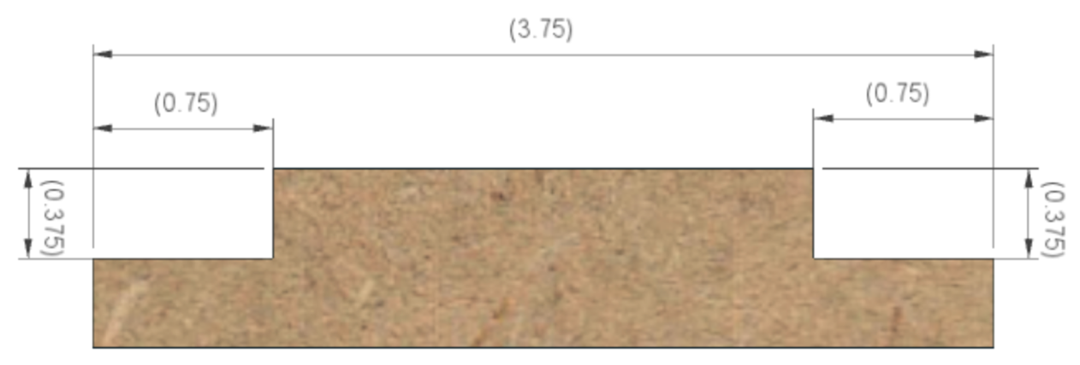

**⅜”**

**⅜”**

**¾”**

**¾”**

**3 ¾”**

### A picture containing building, brick, sitting, small Description automatically generatedH6U & H6L – Bottom

**3 ¾”**

The bottom consists of two pieces. This is a modification from the way the original MDF Rose Engine lathe was built.

The cut in this design for these forms a “funnel”, allowing saw dust to fall thru the bottom of the headstock. This makes it easier to keep it cleaner over time.

The reason two pieces are used is to ensure the rigidity of the headstock when in use, as rigidity is necessary for the quality of the cuts.

The outside dimensions are shown to the right. These are often sized after the other pieces are put into place, but the sizes of 8” x 3 ¾” are a good starting point. The picture to the right shows these when viewed from the top.

**H6U**

**8”**

**H6L**

If these two pieces were cut crosswise, you would see the angles on the inside as shown below. This makes the funnel shape.

It is noted here is 45°, but this angle is not critical (that is what was used for the CAD modelling).

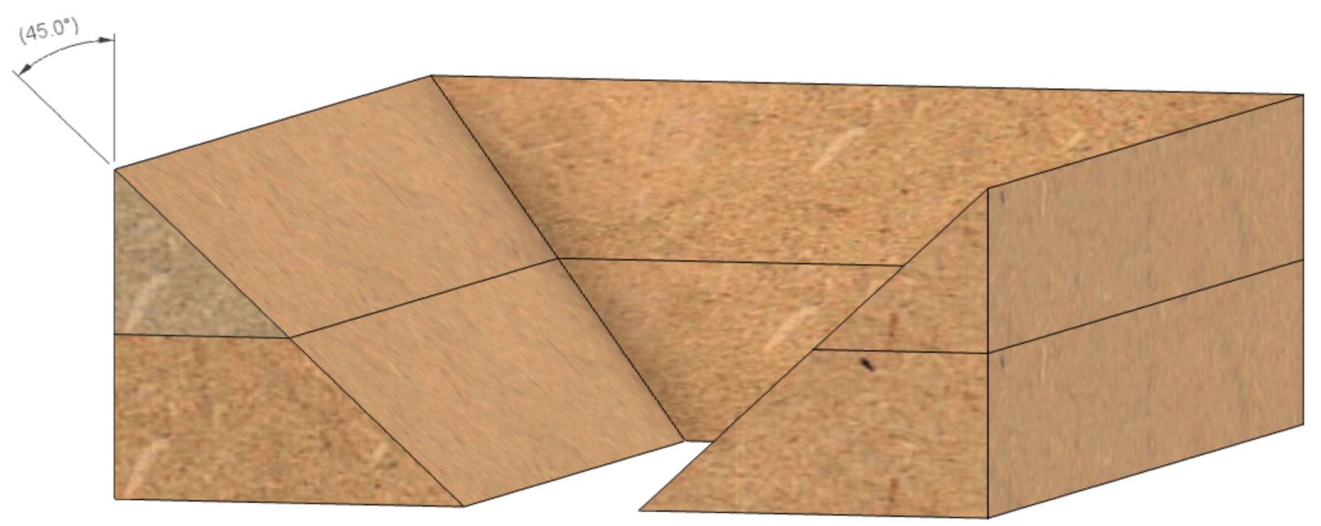

**45°**

**45°**

**H6U**

**H6L**

**Note :** the inside bevels for H6L could be changed to make the opening bigger (i.e., decreasing the angle to 20° or less, making them more vertical).

That may be worth considering as occasionally you will drop a screw or something else into the headstock. Having the item fall thru to the opening in the base is quite convenient as it makes retrieving it much easier.

## Assembly of the Headstock

The next set of instructions should be followed for the assembly of the headstock.

### Dry Fit Everything

Dry fit the pieces, and then cut **H5** and **H6** as necessary to fit.

### Prior to Assembly of the Headstock

Shellac, wipe-on polyurethane, and paint are all typical, and simple finishes for MDF. If you want to finish your lathe, now is a good time to finish it, especially the inside faces of the pieces. Finishing the inside of the headstock is difficult to do after the parts are assembled.

### Assemble the Headstock

**Notes :**

1. When assembling the pieces, it is best to use the spindle and bushings to align **H3** and **H4.** These can be inserted into the holes that were drilled.

1. Jon recommends these be assembled using biscuits or dowels. Either way your alignment is greatly aided, and this is highly recommended.

Once you are satisfied with the fit and the finish, glue the pieces together, and clamp them overnight. Yellow glue works well.

1. Attach two of the T-tracks to **H2**.
2. Attach the other two T-tracks to **H5**.
3. Glue **H1** to **H3**, **H4U**, and **H4L**. This will become the basis for attaching the rest.
4. Glue **H5** into place.
5. Glue **H6U** and **H6L** into place.
6. Glue **H2** into place.
7. Clamp everything together and let it sit overnight.

## After Assembly

After the headstock is assembled, you are still not complete. The instructions below should be followed.

### Headstock Tensioning Bungee

The headstock is pulled towards the Rubber Support column (part of B3) using a bungee cord (the red cord in the picture below – though your bungee’s cord color may differ). The wooden block is held in place on the Rubber Support column (part of **B3**) by the T-Track on the side next to **A1A**.

**Headstock Tensioning Bungee**

Details on making the Bungie Block are on pg. 38.

### Headstock Bungee Mount

The bungie button used for the bungee cord to pull against the headstock is shown to the left (the little white button circled in red).

This button can be made from a hardwood or plastic (e.g., HDPE or even PET).

The button should be ½” to 1” in diameter, and around 3/8” thick.

The groove cut in the button for the bungee needs to be 1/8” to 3/16” wide. Some recommend a round-bottom groove, others a V shape. Neither shape is really critical for this.

**Headstock Bungee Mount Point**

The button needs to be attached to the top of the **H4U** piece so that it is

* centered horizontally, and
* positioned vertically so that it does not project above the top of the headstock (so, if you have a button which is 1” in diameter, then the center of the screw used to secure it would be ½” to ¾” down from the top). Be sure to not position it so low that it interferes with the bushing for the spindle (the brass piece in the picture to the right – that picture is an old one for the original MDF rose engine lathe, and thusly does not show the T-Track. None-the-less, the placement of this piece has remained consistent.).

### Stepper Motor Mounting

The stepper motor drive (shown to the right) is a great upgrade.

The bracket used to hold the stepper motor and tension the belt is shown to the right as the metal piece outlined in red.

This bracket is provided in the **Multiple Stepper Motor Controls Kit.**

### H1 & H2

You will need to drill holes in **H1** and **H2** as shown below (the holes with red circles around them).

The holes marked for ¼” and 13/32” (on the next page) are for the stepper motor mount. They are not needed if you build your machine for hand-cranking.

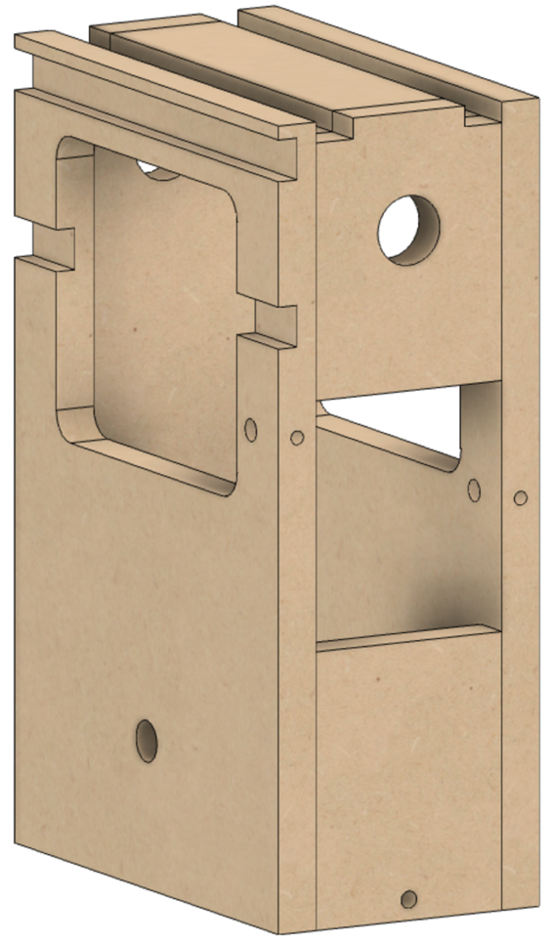

The 13/32” and ¼” holes need to be aligned: Front and side of **H1**, and the same on **H2**.

They are used for the screws with dowel nuts (AKA, barrel nuts).

**Stepper Motor Mounting Bracket**

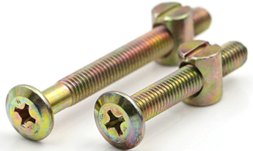

**Note**: The vertical position for the hole drilled in H1 (on the right side of the picture below) needs to be set based on alignment using the stepper motor bracket.

**Typical Screws with**

**Dowel Nuts**

Typical dowel nuts are McMaster-Carr part number 90835A210.

**¼’ Diam**

**5 5/8”**

**5 5/8”**

**1”**

**¼’ Diam**

**H4U**

**H1**

**H2**

**H4L**

**25/64” Diam**

**H2**

**H1**

**25/64” Diam**

# Lathe Base Instructions

The next set of instructions are for building the base. The base is these pieces, and those shown on the next page:

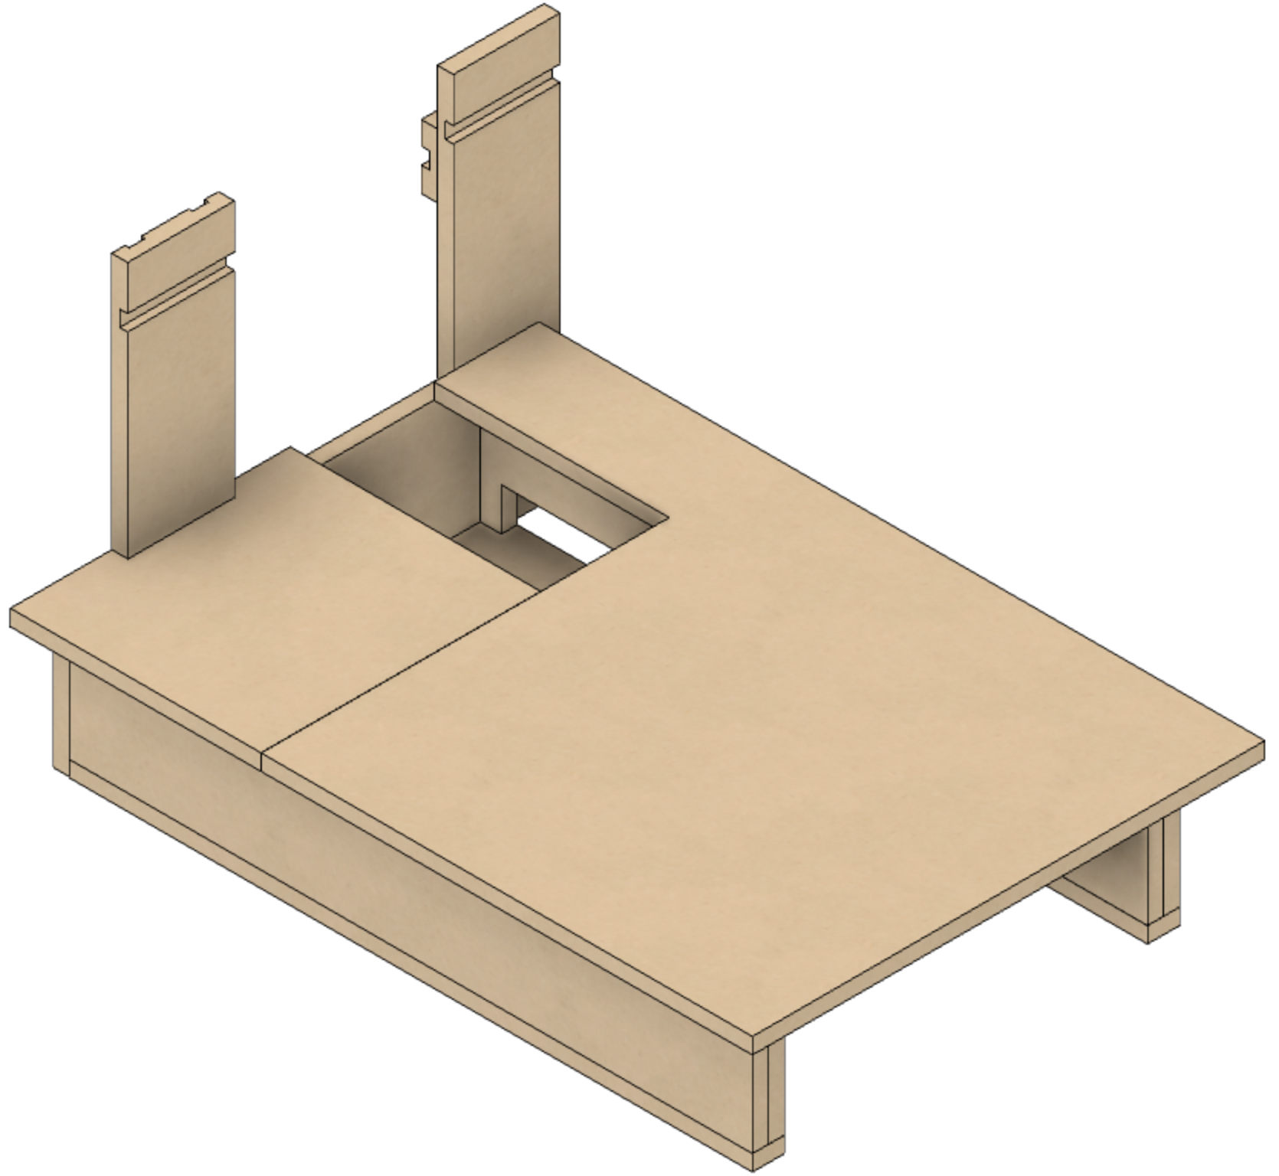

* **B1** – Bed of the lathe.
* **B1A** – Remainder of the bed of the lathe. (This area is often used for storing tools, so it is separated off from **B1**.)

**B1A**

**B1**

Removing **B1** and **B1A**, we have the picture on the next page. The remainder of the parts are described there.

### Inside Pieces Labeled

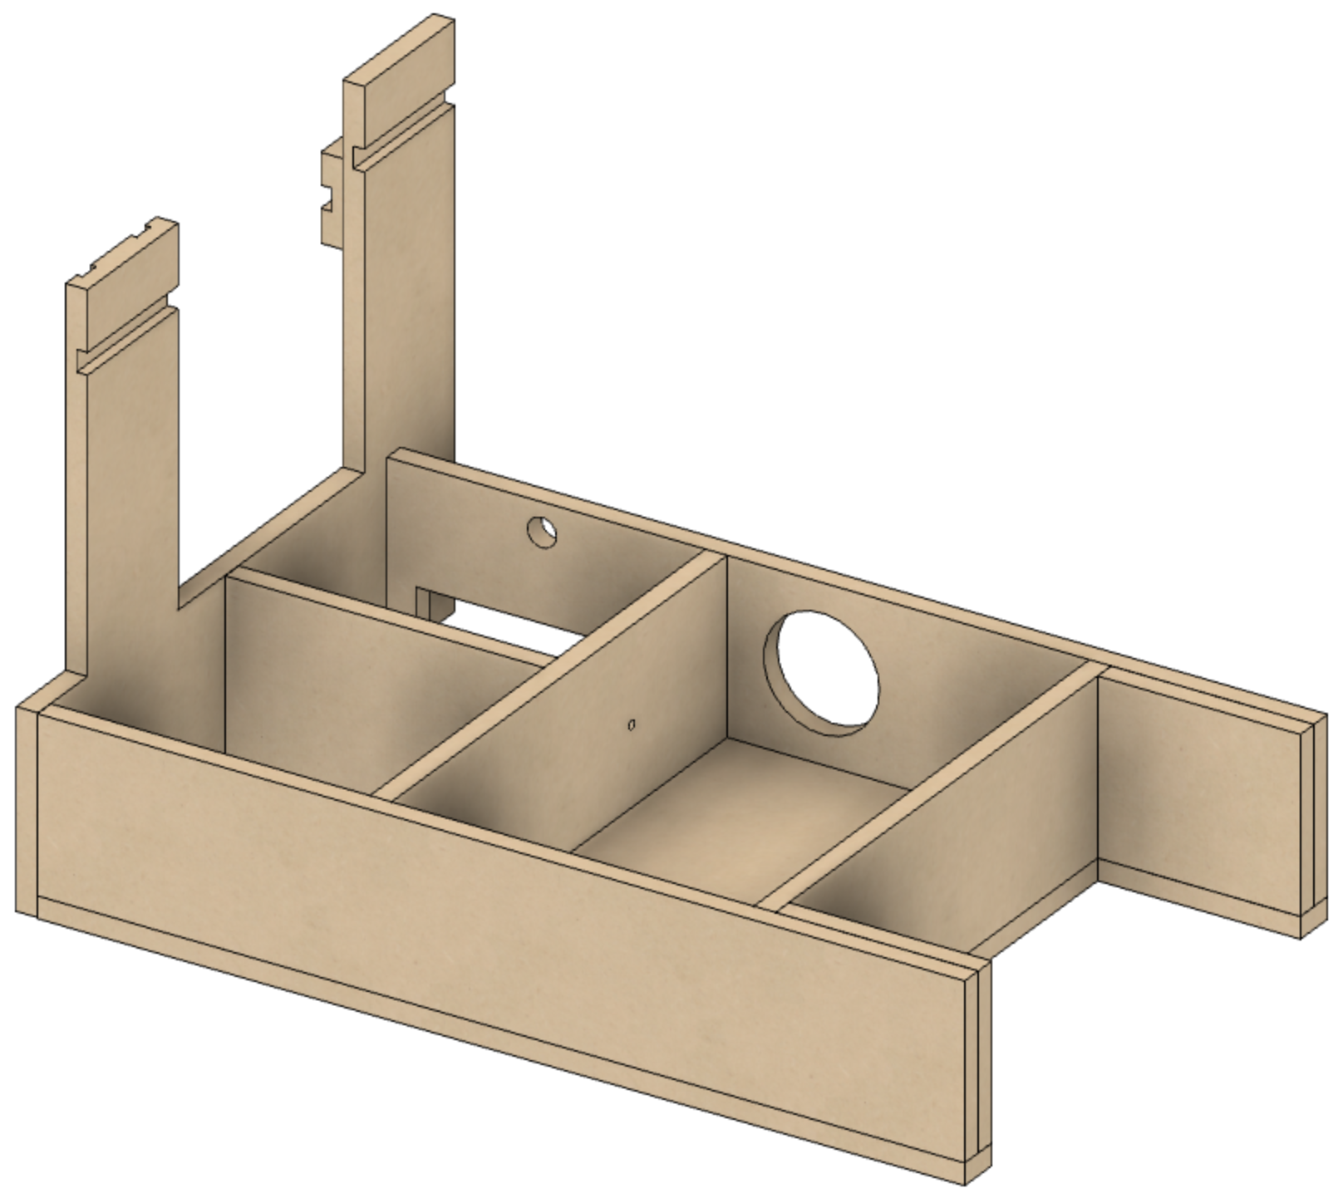

* **B2** – Bottom.

**RS2**

* **B3** – Left side.
* **B4** – Left side support for **B1**, and one mount for the headstock pivot point.
* **B5** – In the old MDF Rose Engine, this was the right side. This was pushed back towards **B3** to accommodate a cutout under the bed. This cutout is used to place the controls for the stepper motor(s).
* **B6** – Rear side.
* **B7** – Back side to support the box area in front of the headstock. Also supports the **B1A** piece.

**B3**

**B6**

**B7**

**B4**

**B10**

**B2**

**B5**

**B8**

**B9**

* **B8** – Front.
* **B9** – Additional support for stability for the front of the lathe’s bed (**B1**).
* **B10** – Additional support for stability for the back of the lathe’s bed (**B1**).
* **RS2** – Rear rubber support

## Before Assembly

These instructions should be followed before assembly of the base.

### B1 – Lathe Bed

**34”**



**24”**

**24”**

**10”**

**5”**

The size of **B1** allows for putting a 24” x 24” piece of sheet metal on the top. The minimum thickness sheet that is 16 gauge (1/16”) thick, though 1/8” steel is recommended by some.

**Do not use aluminum**: the metal must be ferrous to allow the MagSwitches to bind to it.

**Option:** One option that has been proposed is to make B1 a square, 24” x 24”. This can be done; however, I found that the area behind the headstock is useful for holding a task light (like shown below). And, in the MDF Rose Engine Lathe 2.0 design, the back (**B6**) is not as close to the headstock, so the spacing block would have to be re-designed.



**B1A**

**B1**

**B1A**

**B1**

### B1A – Lathe Bed

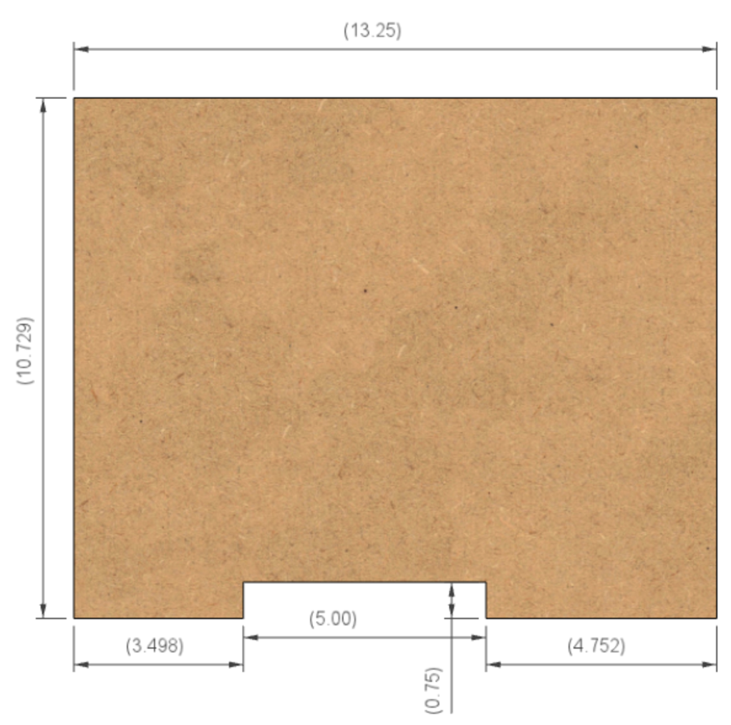

**5”**

**¾”**

**4 ½”**

**3 ¼”**

**10 ¾ ”**

**12 ¾”**

This piece covers the area that had been used for the hand crank. With a stepper motor, this is not necessary.

If using this as a cover you will remove often, consider making these changes:

1. Reduce the width by 1/8”, making this 10 5/8”.
2. Open this up to 5 ¼”, taking 1/8” off each side.

### B2 – Lathe Bottom

**32”**

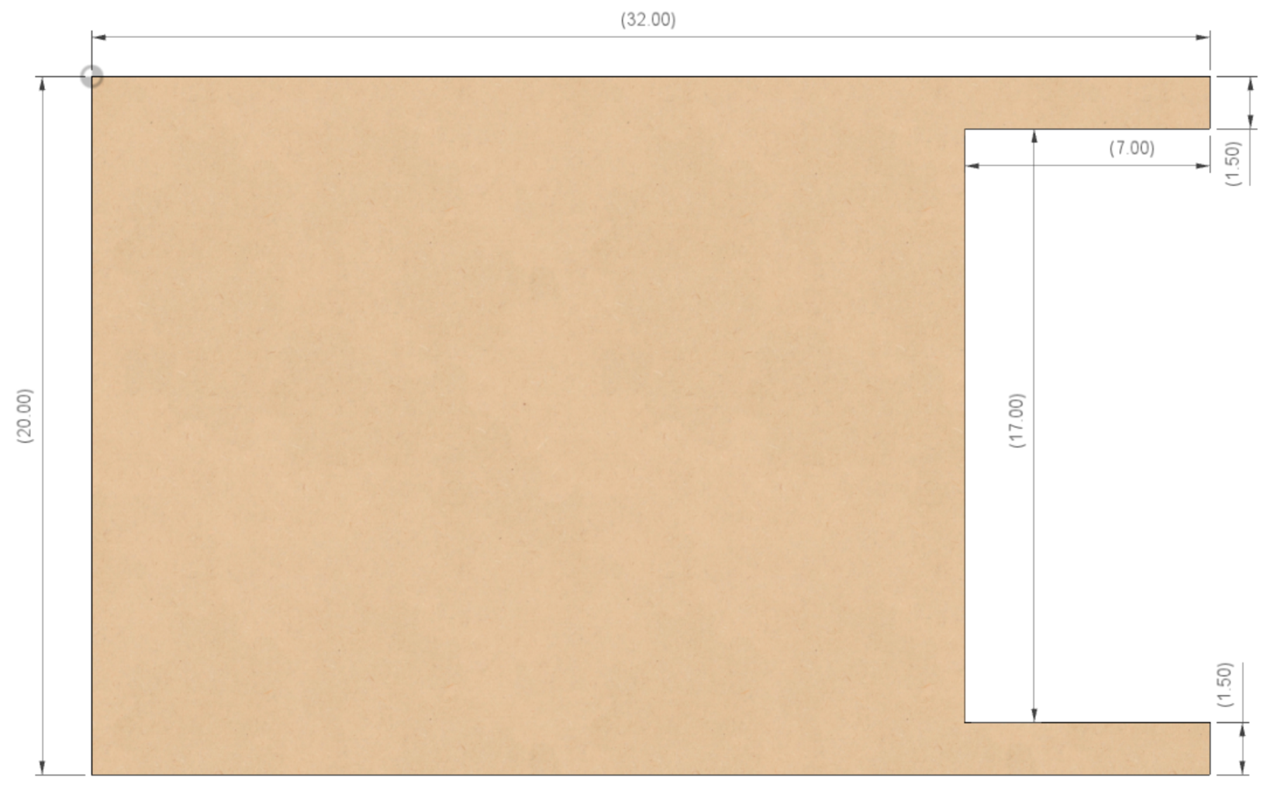

**1 ½”**

**1 ½”**

**7”**

**17”**

**20”**

### B3 – Left Side

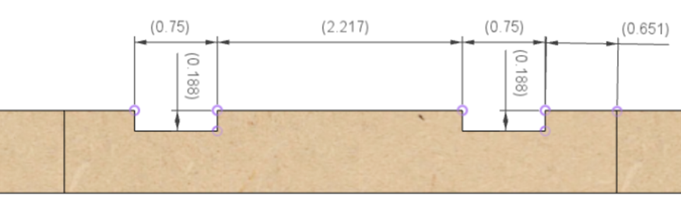

**¾”**

**¾”**

The cuts for the T-Track on this side are shown in the top view (the top pic). The T-Track is set to be proud of the surface, 50% (3/16”) below it and 50% (3/16”) above. This is designed to use T-Track which is ¾” wide x 3/8” tall.

**5/8”**

**2 ¼”**

**3/16”**

**3/16”**

These T-Tracks are used by the **RS-1** rubber support.

**5”**

**5”**

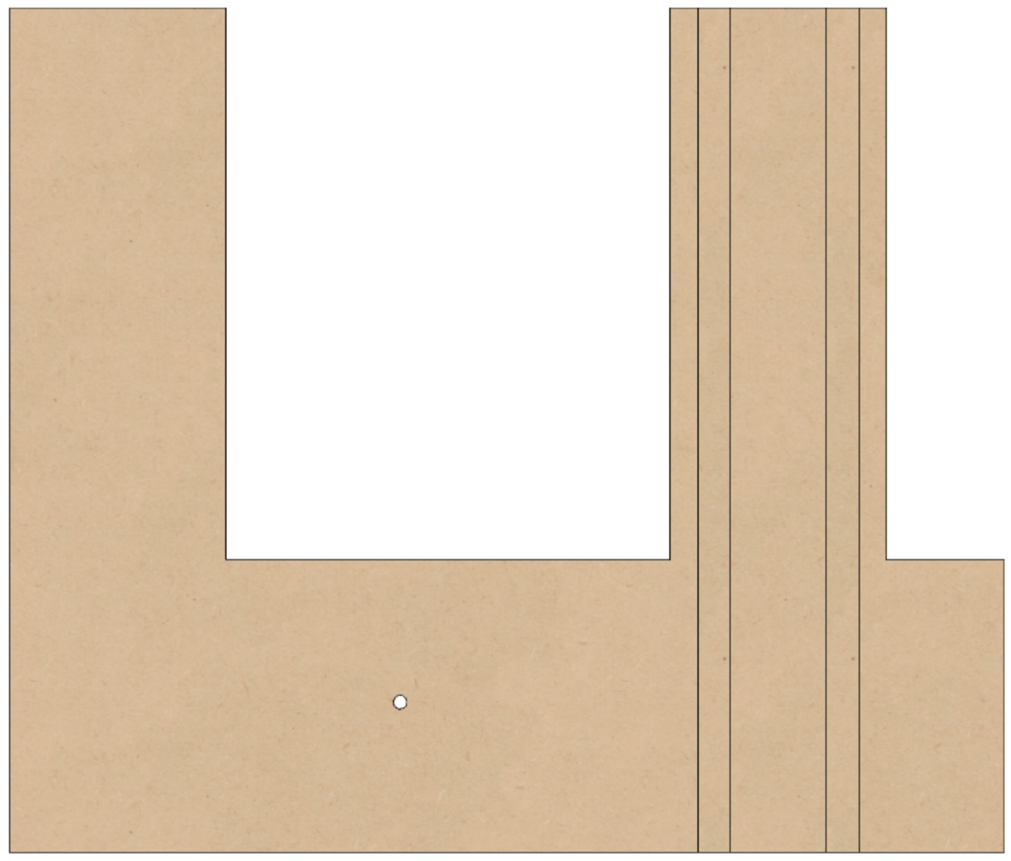

**12 ¾”**

**23”**

**6 ¾”**

**19 ½”**

**2 ¾”**

The cuts for the T-Track on this side are shown in the side view (the right pic). The T-Track is set to be flush with the surface. This is designed to use T-Track which is ¾” wide x 3/8” tall.

These T-Tracks are used for the headstock bungee.

**3 ½”**

**9”**

**3/8”**

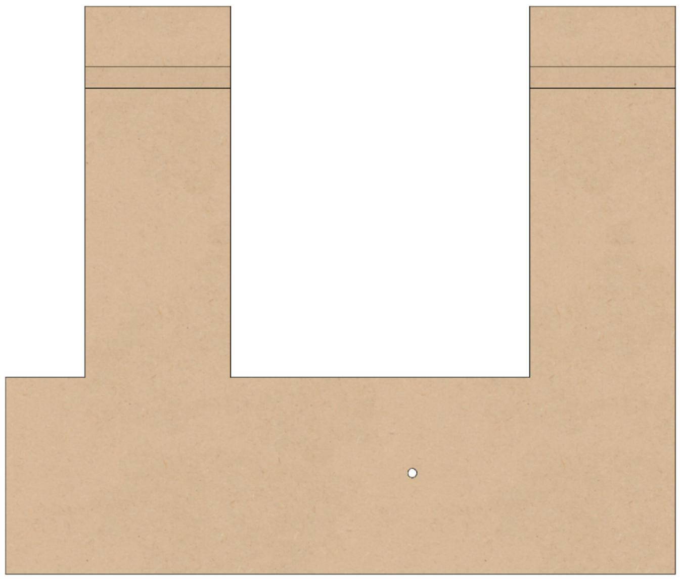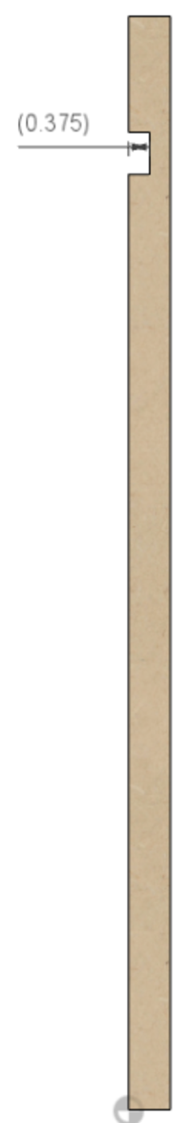

**2 1/8”**

**2 1/8”**

**¾”**

**¾”**

A hole is needed in **B3** for the headstock’s pivot point (see also, picture below). This hole is for the T-nut. The T-nut is used to hold the adjustable pivot for the headstock to rock on.

The flange of the T-nut should be on the inside of the base, facing the **B4** side (see also, the picture below).

1. Counter-bore for the T-nut. The goal is to set the T-nut flush with the MDF. Measure the OD of your T-nut and the flange thickness, then counter-bore **B3** from face that will be facing towards the headstock. A typical 3/8”-16 T-nut will have an OD of 1” and a flange about 1/16” thick.
2. Also measure the body of the T-nut and counter-bore for that next. Typical T-nuts will need a 29/64” drill for the body, about ½” deep.
3. Finally drill through with a 25/64” drill for the 3/8” pivot screw to pass through.

### 

**View from the Back, Looking Towards the Front**

### B4 – Inside

**18 ½”**

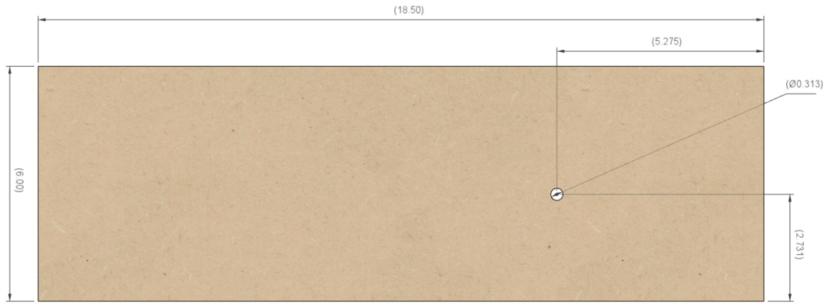

**(see notes)**

**5 ¼”**

**2 ¾”**

**6”**

A hole is needed in **B4** for the headstock’s pivot point. The instructions for this hole are the same as for **B3**, with the exception that the flange for **B4** is facing the **B3** side (see also, the picture below).

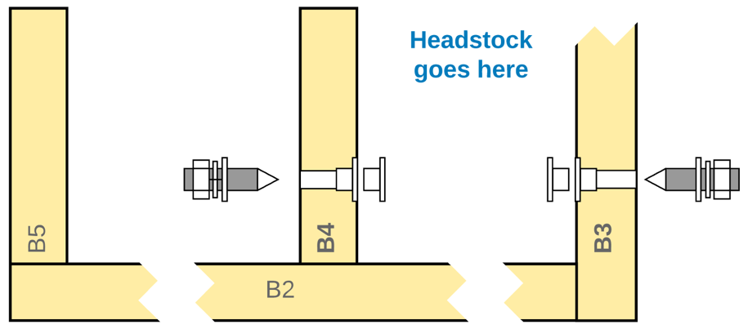

**View from the Back, Looking Towards the Front**

### B5 - Inside

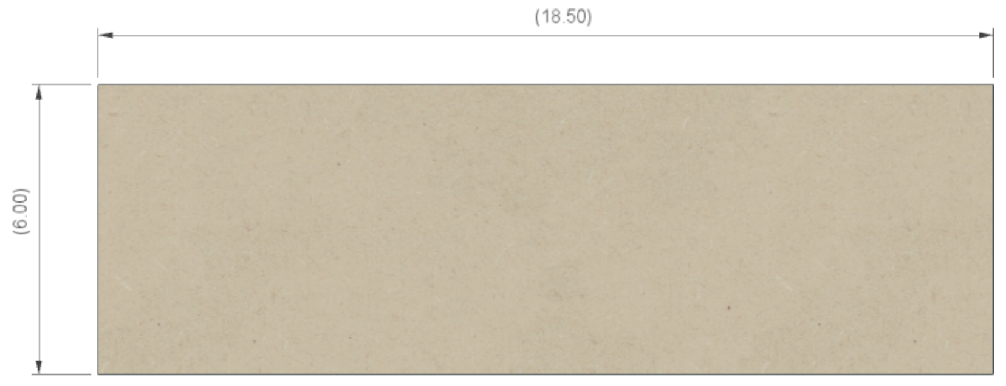

**6”**

**18 ½”**

### B6 - Inside

**Transporting the machine?**

Remove the headstock from the bed to prevent damage.

A 4” diameter hole has been added to this piece to enable easier access to the headstock’s inside pivot points. This is a useful feature to have as it alleviates the need to remove the top (B1) to access these.

**4” diam**

**1” diam**

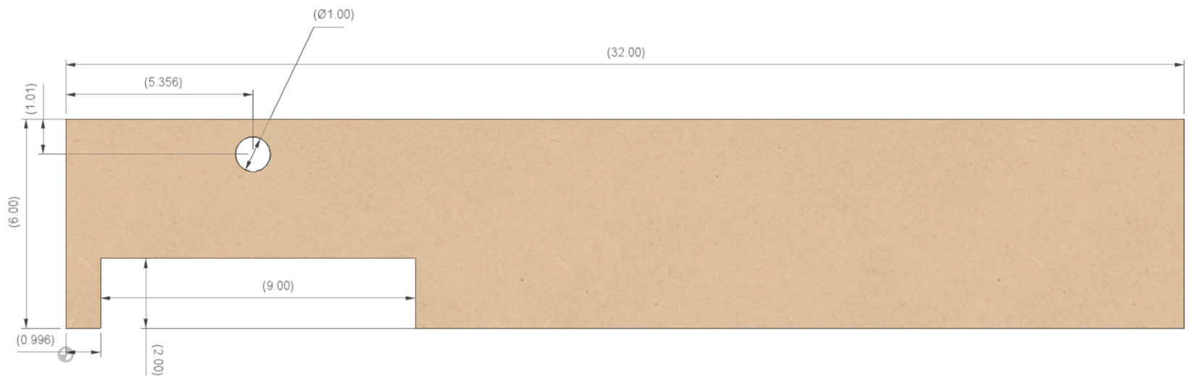

**16 ½”**

**6 ¼”**

**5 3/8”**

**2”**

**1”**

**32”**

**1”**

**6”**

### B7 - Inside

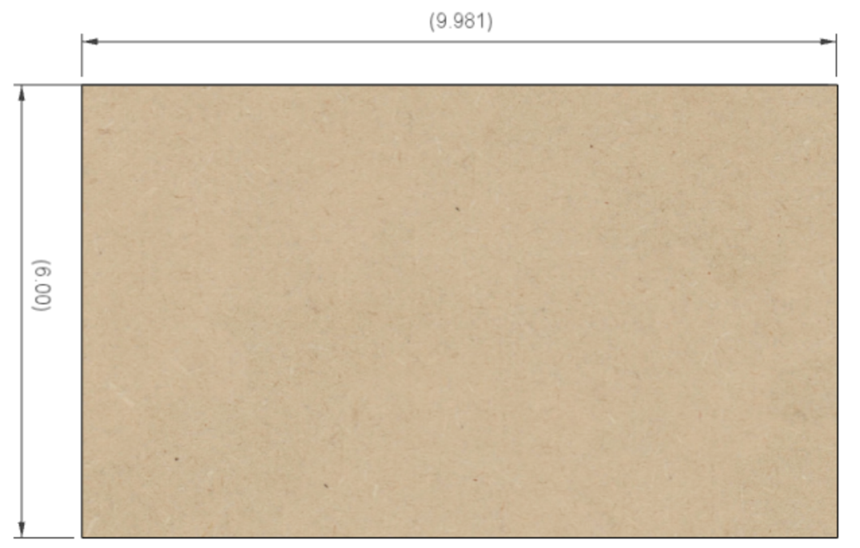

**10 ¼”**

**6”**

### B8

**32”**

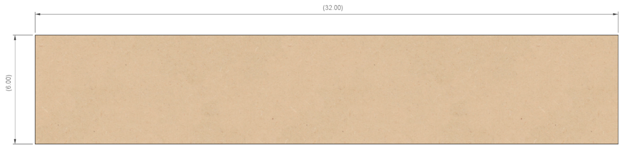

**6”**

****I chose to not put the openings in this piece, though you can if you wish. Something like the cutouts below is possible. If you pursue this option, I recommend you mark for the openings after dry fitting this piece to the others. That way you can be sure your openings will not expose the ends of the **B4** and **B5** pieces.

The picture below shows an example of **B8** in place on the complete machine and spacing around **B4** and **B5**.

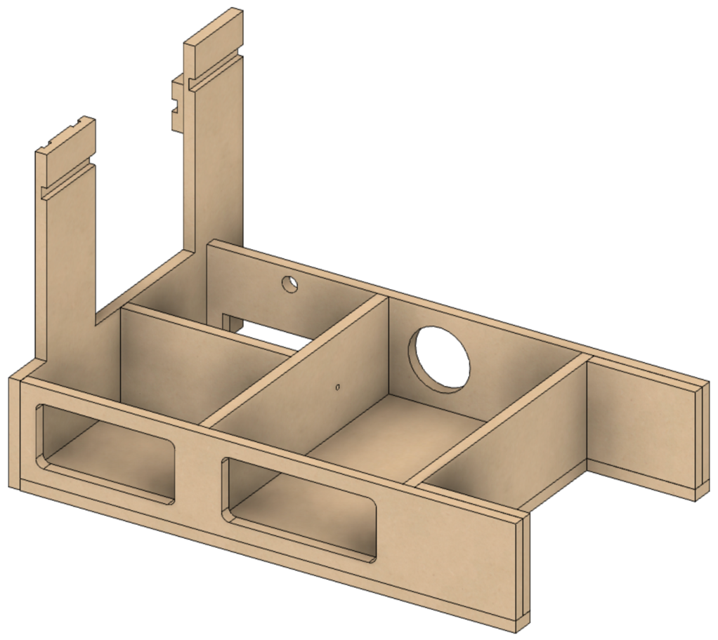

### B9 & B10

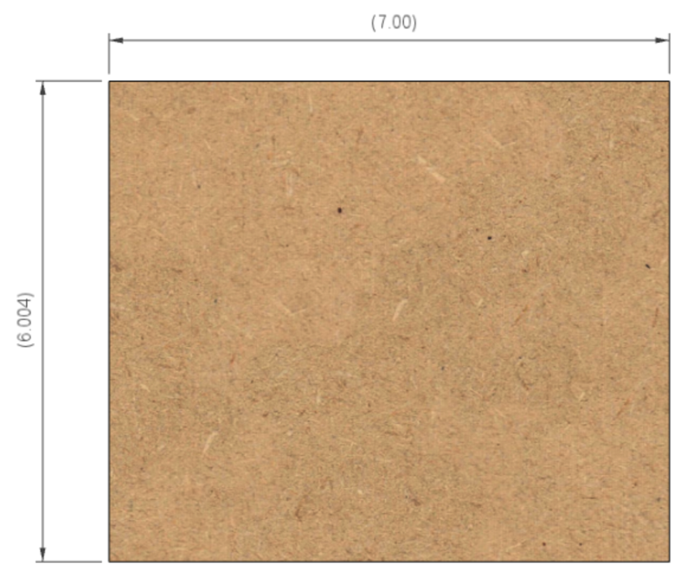

**6”**

**7”**

## Rubber Support

The rubber support columns on **B3** have two blocks that are used to position the rubber(s).

**B3**

* **RS1** is used to hold the front rubber. It is moveable up and down for usage of an amplitude adjuster.
* 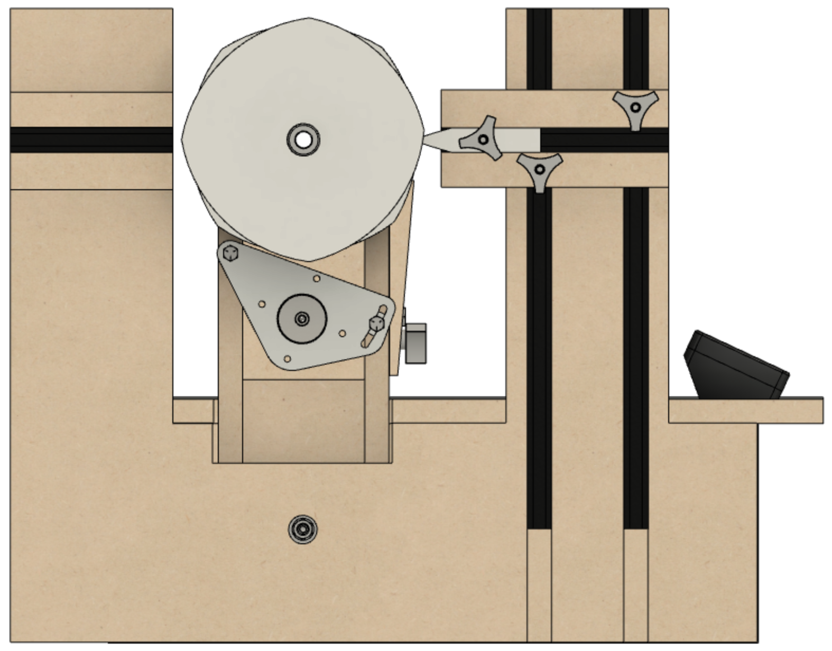**RS2** is used to hold the rear rubber when one is used. It is fixed in place as no amplitude adjuster would be used with the rear column.

**RS1**

**RS2**

### A piano in a room Description automatically generatedRS1 – Front Rubber Support

**RS1** is used to hold the rubber and allow for rubber to be moved in or out (relative to the spindle), and up or down. The vertical alignment of the front rubber allows for the use of an amplitude adjuster. For the vertical alignment, **RS1** rides on the T-Track. The overlap of the T-Tracks is shown in the picture to the right.

**Top View – Showing RS1 Installed**

**A1A**

**B3**

**RS1**

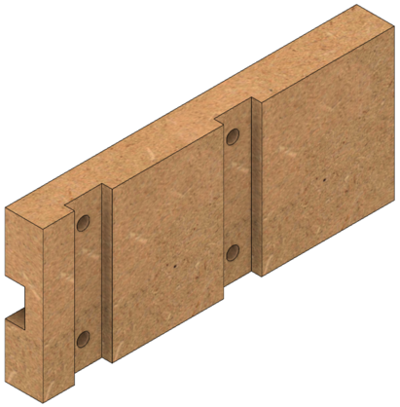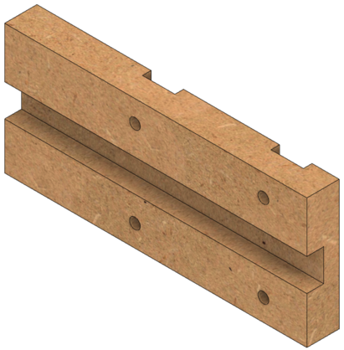

2 to 4 holes are needed for the T-Track screws. The holes need to be ¼” diameter.

**Right Side**

**Left Side**

**¼ ” diam. (typ)**

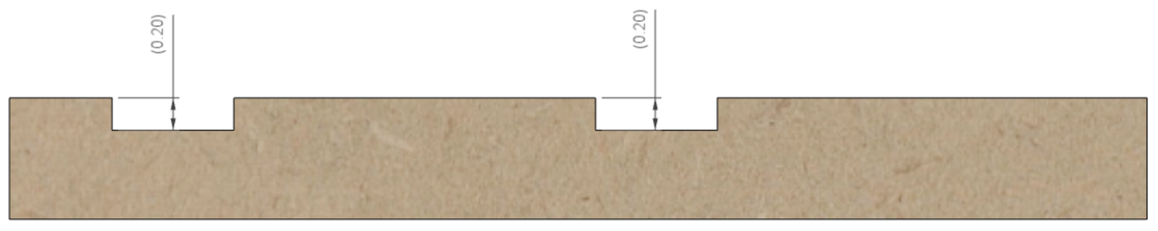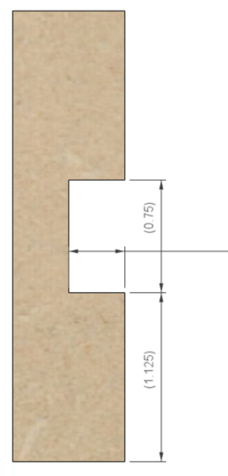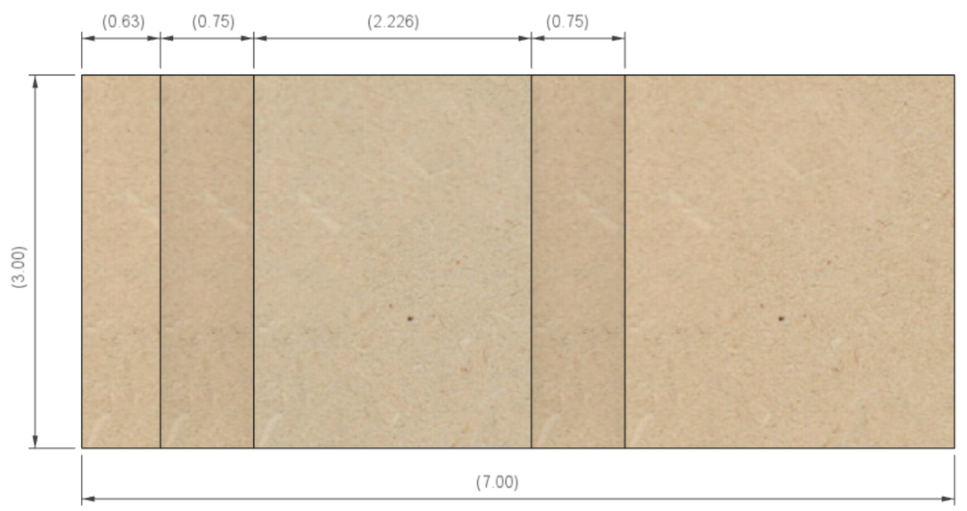Vertical spacing on these is not critical, however they must not overlap into the horizontal T-Track.

**¾”**

**3/16”**

**3/16”**

**¾”**

**2 ¼”**

**¾”**

**5/8”**

**3/8”**

**1 1/8”**

**3”**

**7”**

### RS2 – Rear Rubber Support

**RS2** is used to hold the rubber on the rear column and allow for rubber to be moved in or out (relative to the spindle). (There is no amplitude adjuster available for the rear rubber support.)

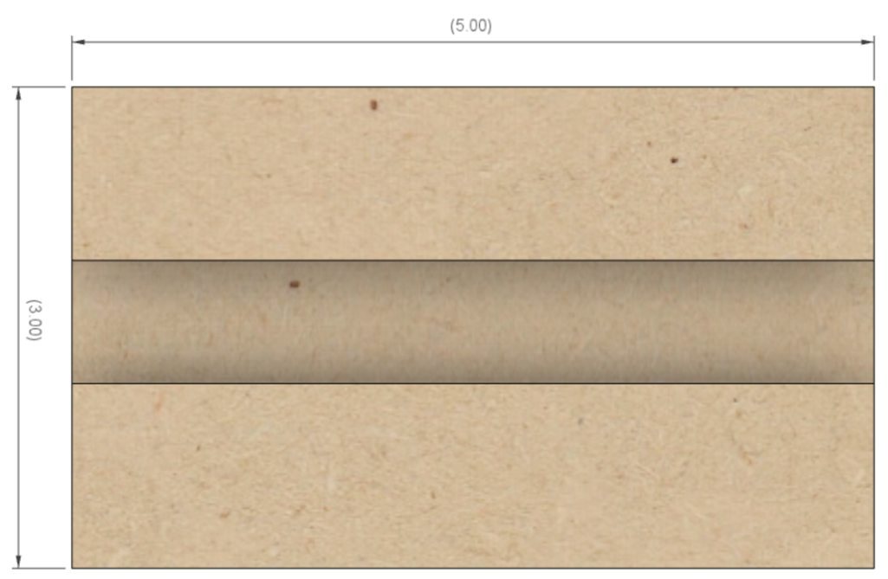

**5”**



**3”**

**¾”**

**3/8”**

**1 1/8”**

## Assembly of the Base

Assemble the pieces of the base, gluing them together and clamping them. The recommended order of assembly is below. The diagram for the layout of all these parts is on pg. 21.

These parts should be glued together, and for certain pieces dowel pins or biscuits are recommended to ensure alignment.

1. Attach **B8** to **B2**, using dowel pins or biscuits for alignment. This will become the basis for attaching the rest.
2. Attach **B3** to **B2** and **B8**, using dowel pins or biscuits for alignment.
3. 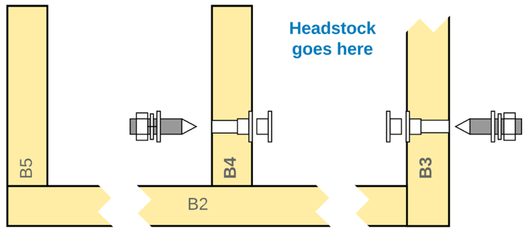Attach **B7**, using dowel pins or biscuits for both alignment and strength.
4. Attach **B4**, using dowel pins or biscuits for alignment. Be sure it is installed the correct direction.
   1. The pivot point’s hole should be 2 ¾” above the base (**B2**).
   2. The indentation for the T-nut should be on the side facing **B3**.
5. Attach **B9** to **B8**. No dowels nor biscuits are needed. Gluing this is sufficient.
6. Attach **B10** to **B6.** No dowels nor biscuits are needed. Gluing this is sufficient.
7. Attach **B5**, using dowel pins or biscuits for alignment. **B5** should press up tightly against **B9** and **B10**.
8. Attach **B6**, using dowel pins or biscuits for alignment.
9. Attach **RS2** to **B3**. It is attached to the rear rubber support column, and the top of **RS2** is 2 ½” down from the top to **B3**. This can be glued into place or attached with screws or a nail gun. Gluing it into place is sufficient.

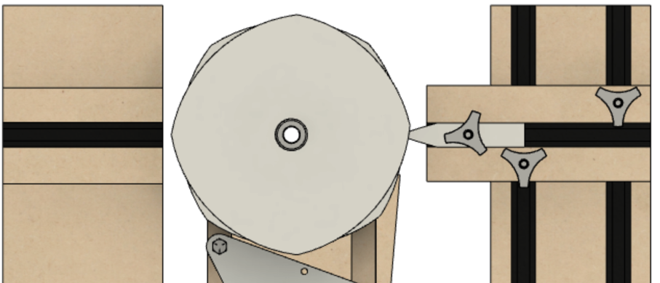

**2 ½”**

**B1** and **B1A** are attached to the rest of the base using screws or other mechanical means. They are NOT glued to the other parts.

1. **B1** is typically screwed into place
2. **B1A** sits on supports and may be screwed into place if desired. It is not critical to do so.

## After Assembly of the Base

Once everything is in place, install the headstock. Secure it in place by tightening the Pivot Set Screws. Secure them in place using the nuts.

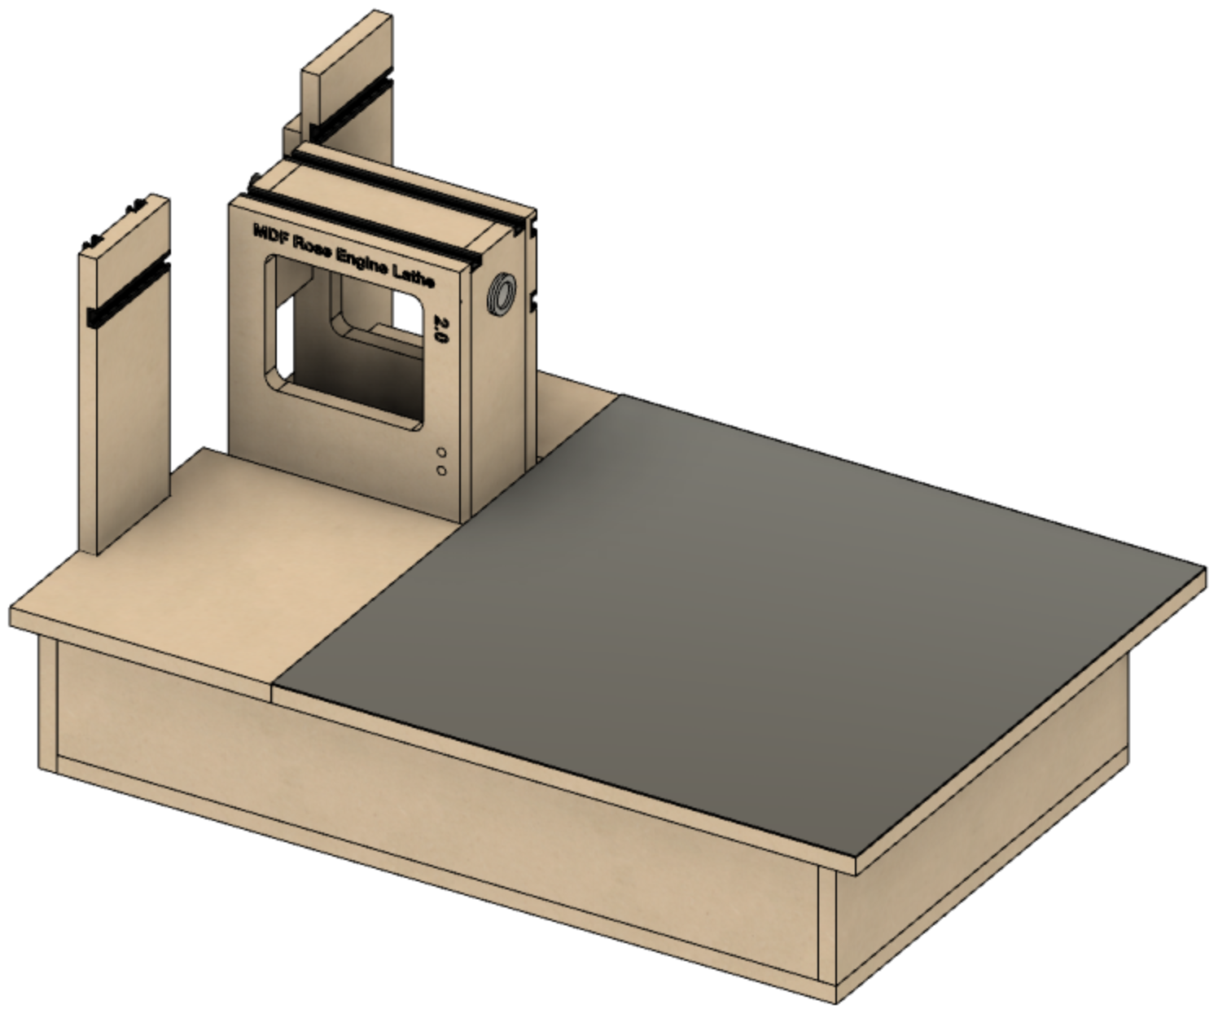Attach a sheet of steel to the top of **B1** as it allows for the use of magnetic switches to secure the cross slide in place wherever needed.

The steel sheet can be attached with two to three flush-mount screws on the far side’s edge. Recommended placement is shown below with the red dots.

Do not attach it on the other edges as the metal will expand and contract with temperature changes, and this will be different than the movement of the MDF wood.

**Steel Sheet**

# Additional Parts

## Centering Block

The only key measurement on the centering block is the thickness – 3/8”. It can be cut from a cube anywhere from 1” to 2”, but 1 ¼” to 1 ½” is most typical.

**1 ½”**

**(+/-)**

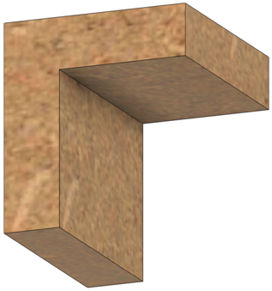



**1 ½”**

**(+/-)**

**3/8”**

**3/8”**

## Bungie Block

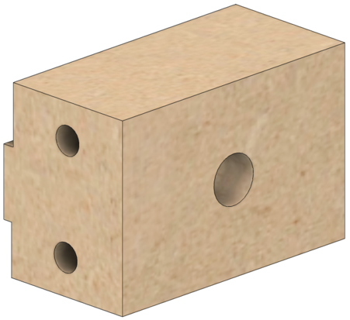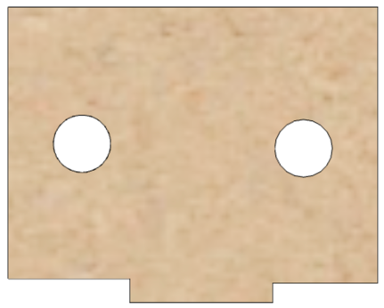

**1 ½”**

**1/4” dia**

**5/32” dia**

**1/8”**

**¼”**

**1”**

**1 1/8”**

**1”**

# Cross Slide Base Instructions

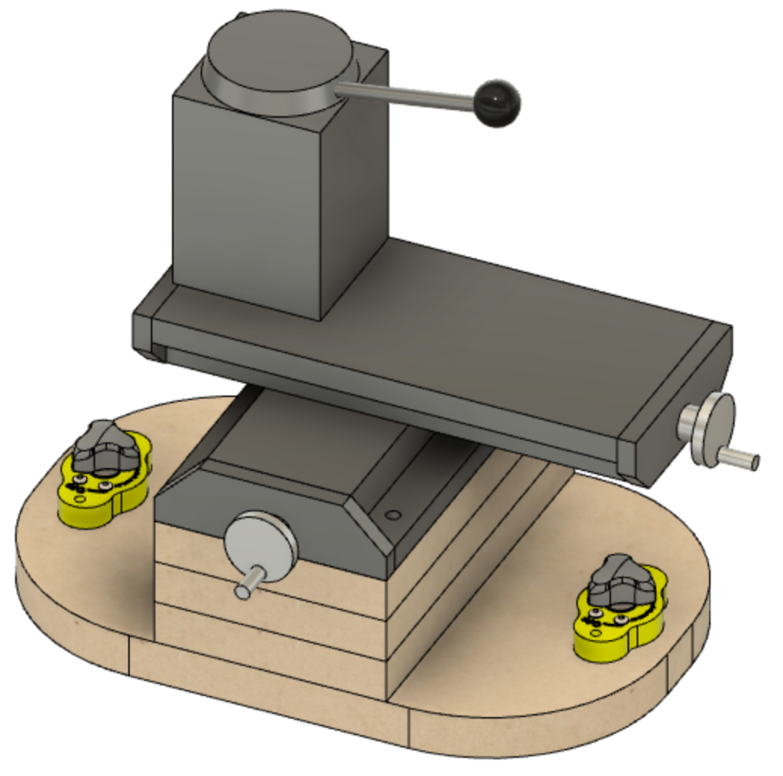The Cross Slide needs to be mounted to a base which enables it to be secured to the steel sheet covering the lathe base (on **A1**).

MagSwitches on each end hold the base secure to the steel sheet.

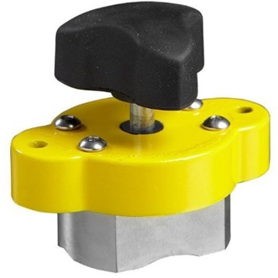

**MagSwitch**

### CS1 – Bottom

The bottom, **CS1**, is as below.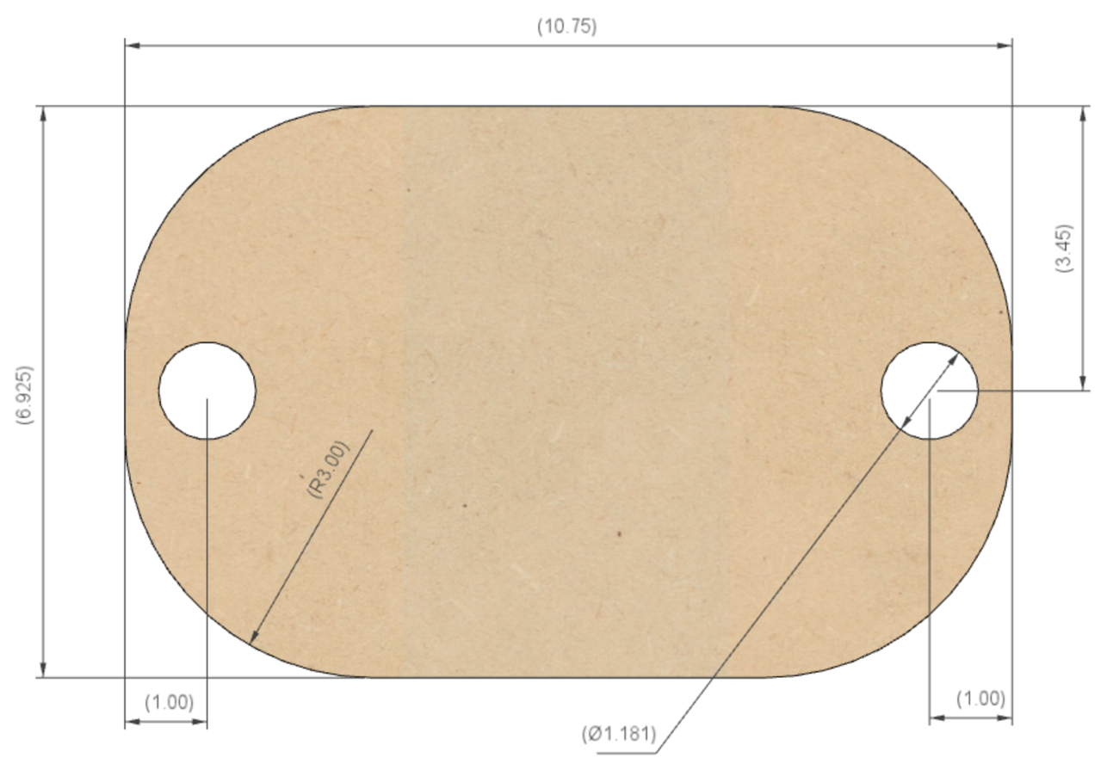 The corners on mine are rounded off with a 3” radius on each of the 4 sides. This is not critical but gives it a nice look.

**3” Radius**

**30mm Diam**

**10 ¾”**

**7”**

**3 ½”**

**1”**

**1”**

The 30mm holes on each end are for MagSwitch 95s. If using MagSwitch 150s, this would be 40mm.

### CS2, CS3, CS4, & CS5 – Spacer Blocks

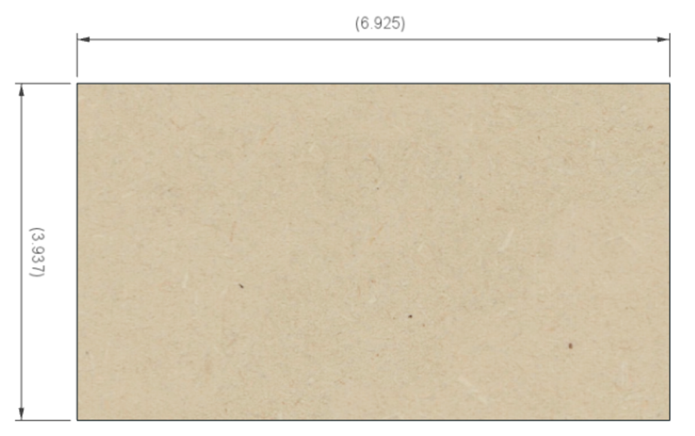There are 3-5 pieces needed to to elevate the cross slide to the proper height:

**7”**

* CS2, CS3, CS4, and CS5 are ¾” MDF, and
* CS6 is ¼” plywood.

**4”**

The cross slide and quick-change tool post from LittleMachineShop.com needs 4 spacers, each ¾” thick and 1 spacer which is ¼”.

Use the necessary pieces according to your cross slide.

## Drilling Holes and Assembly

The holes that need to be drilled in these pieces is noted below. Start with **CS1**.

1. Drill the 30mm holes first. These are for the MagSwitches (picture on previous page). It is a good idea to set them in the holes and then drill small pilot holes on the sides for the screws (or nails) needed to hold the MagSwitches in place.
2. 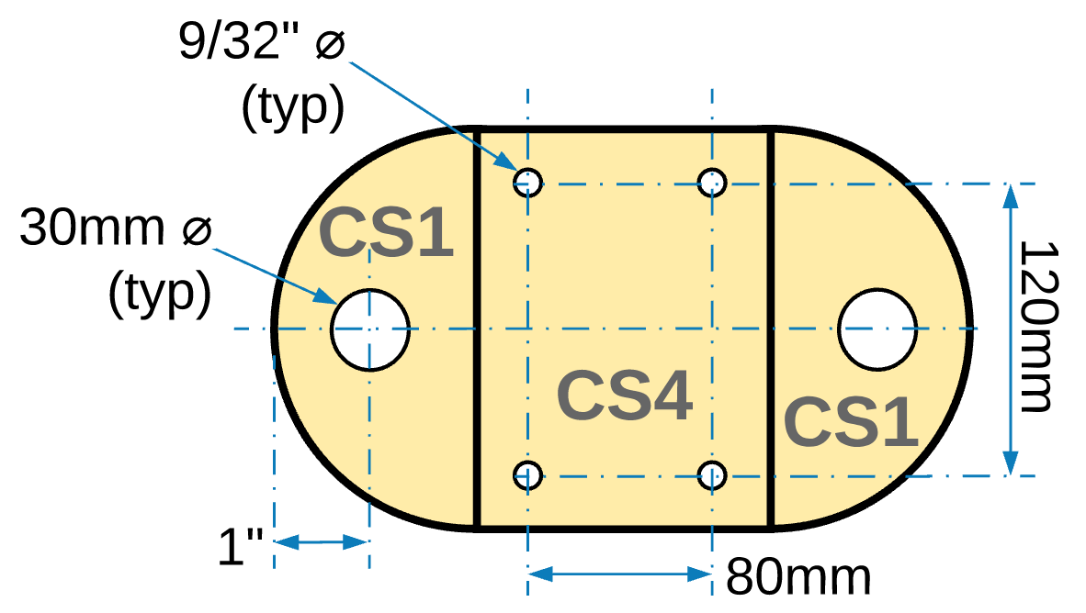Next, drill the 3/4” recesses on the bottom of **CS1**. These need to be deep enough to ensure that the bolt heads do not project down below the surface of the wood. 3/4" was selected to allow the bolt to be held by a socket. Depending on your socket’s size, these may need to be larger.   
     
   The centers for these holes need to be aligned according the fastening holes for the cross slide. The one from LittleMachineShop, part # 2008, has holes spaced at these dimensions. Ensure they match the cross slide you have selected.  
     
   These ¾” holes are drilled first as the points on the Forstner bit will leave a small divot which will be used for centering the next holes to be drilled.
3. Holding all 4 pieces together, drill the first 9/32” hole through all 4 pieces. Insert one bolt and snug it down.

**Top View**

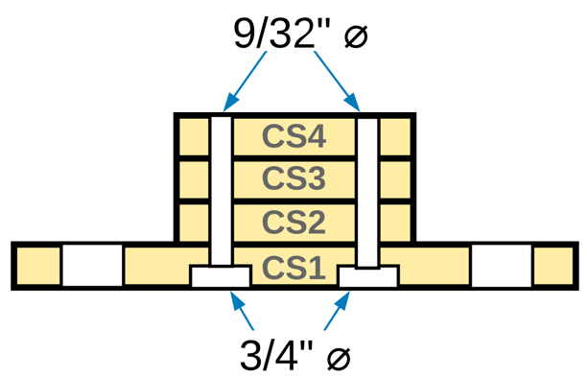

1. Drill the hole in the opposite corner and insert a second bolt and snug it down.
2. Drill the remaining 2 holes.

CS5 and CS6 would be added to the stack along with CS2 thru CS4.

Assemble the entire set using the 1/4”-20 carriage bolts. Depending on the number of spacer blocks needed, you will need up to 5” long bolts.

**Side View**

# Document Version History

|  |  |  |
| --- | --- | --- |
| Ver | Date | Comment |
| 1.2 | 04 Sep 22 | Updated for being able to CNC cut all MDF pieces. |
| 1.1 | 04 Apr 21 | Bryan Boston found some errors in the document, and some other items which needed more clarity. These have been updated. |
| 1.0 | 01 Dec 20 | Initial document |

To the extent that material may appear to be infringed, we assert that such alleged infringement is permissible under fair use principles in U.S. copyright laws. If you believe material has been used in an unauthorized manner, please contact me at [ColvinTools@Gmail.com](mailto:ColvinTools@Gmail.com).

Portions of this document are copyrighted by Jon Magill and are used with his permission.

Permission is not granted to manufacture these for sale.